**REGISTER_PROJECT**

**VALIDATION SENARIOUS**

FOR FIRSTNAME FIELD

1] ALL FIELD IS REQUIRED.

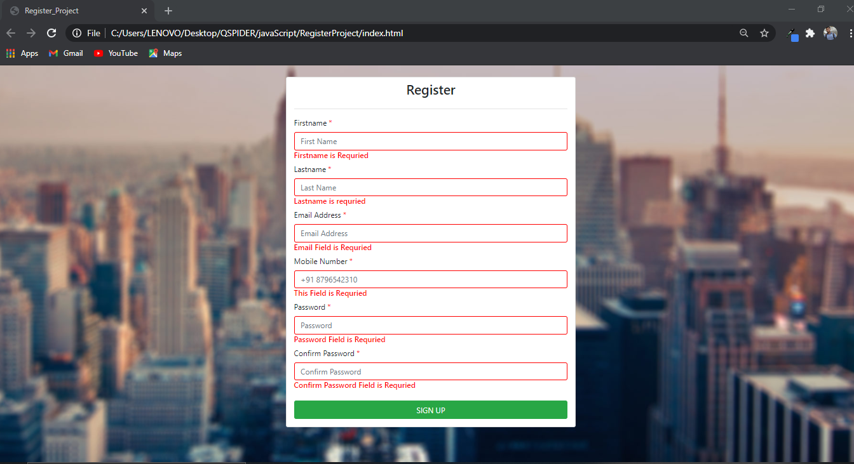

2] FIRSTNAME, LASTNAME, EMAIL, MOBILENO, PASSWORD IS REQUIRED.

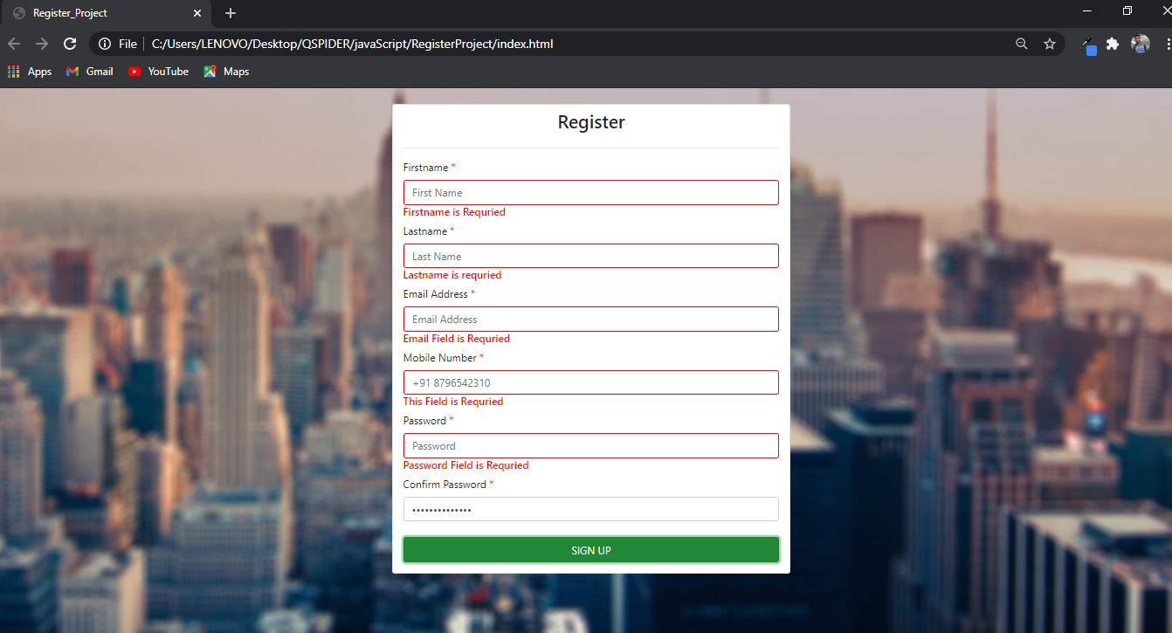

3] FIRSTNAME, LASTNAME, EMAIL, MOBILENO IS REQUIRED.

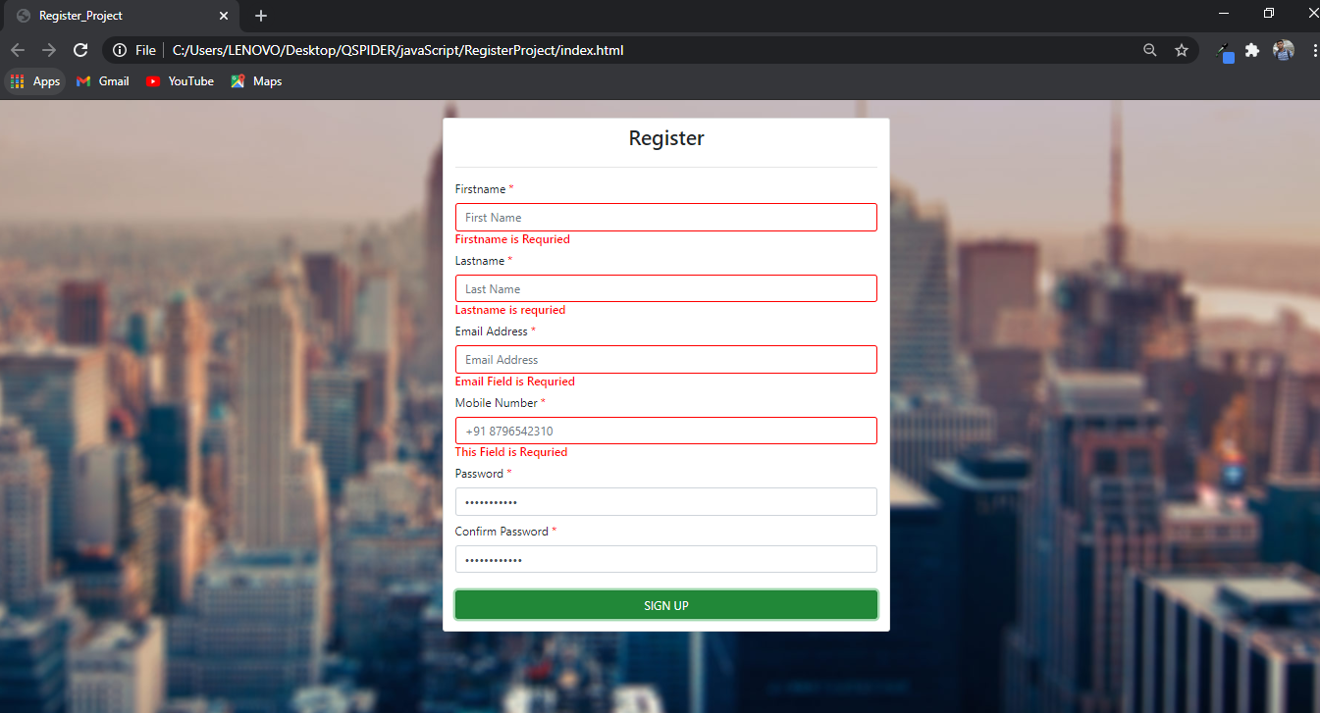

4] FIRSTNAME, LASTNAME, EMAIL IS REQUIRED.

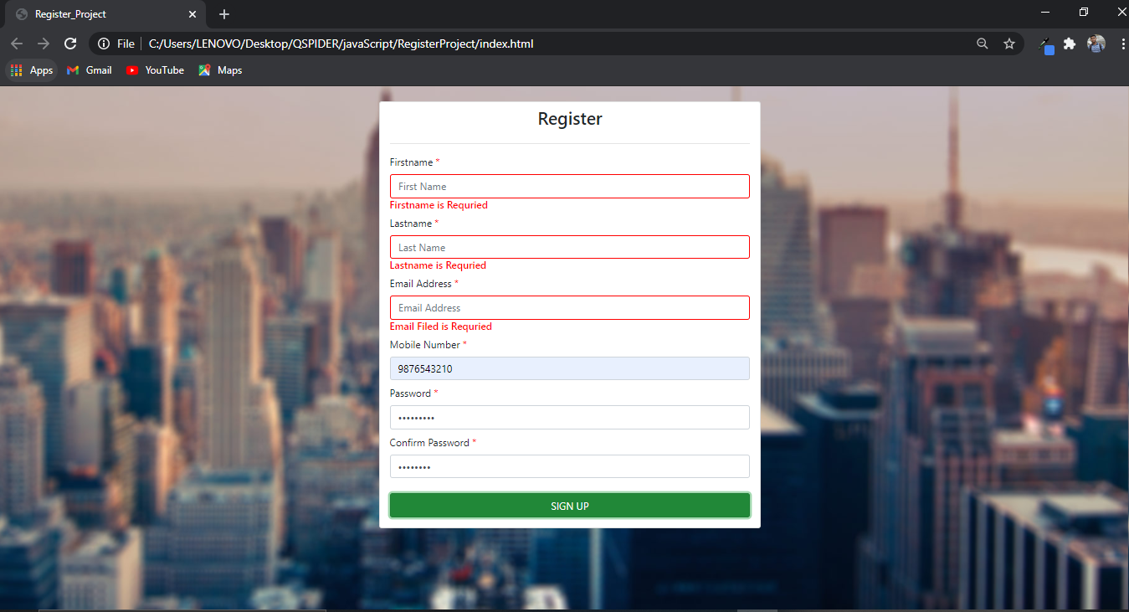

5] FIRSTNAME, LASTNAME IS REQUIRED.

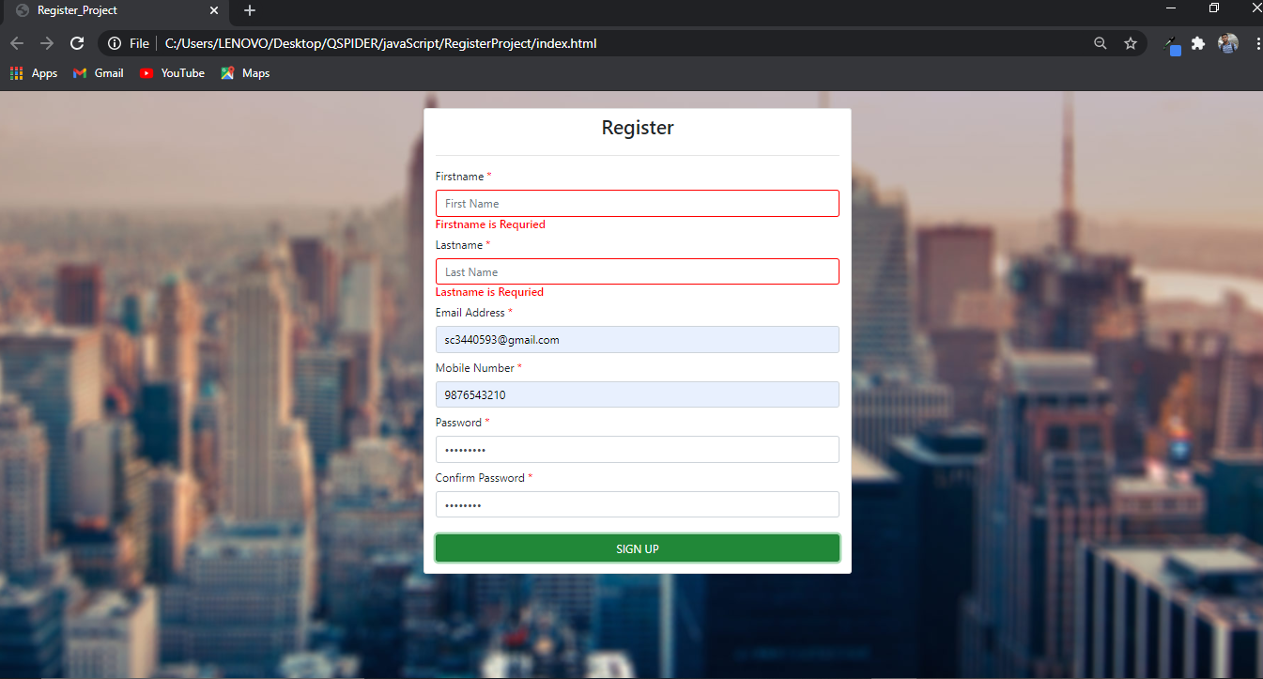

6] FIRSTNAME, EMAIL IS REQUIRED.

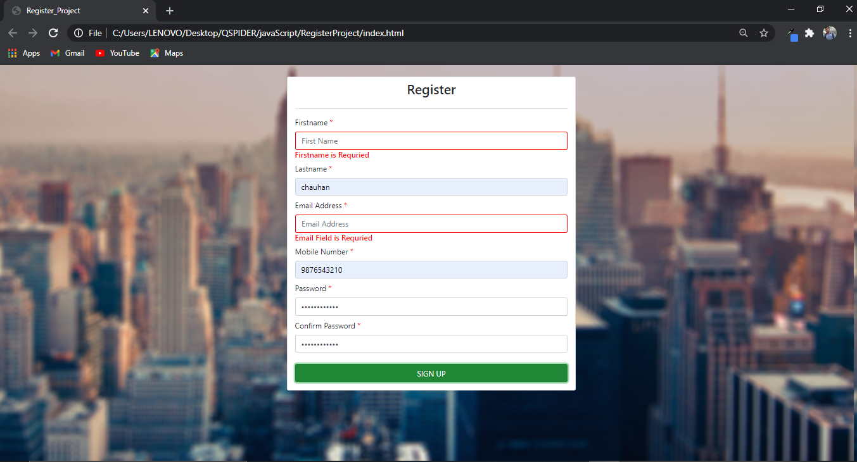

7] FIRSTNAME, MOBILENO IS REQUIRED.

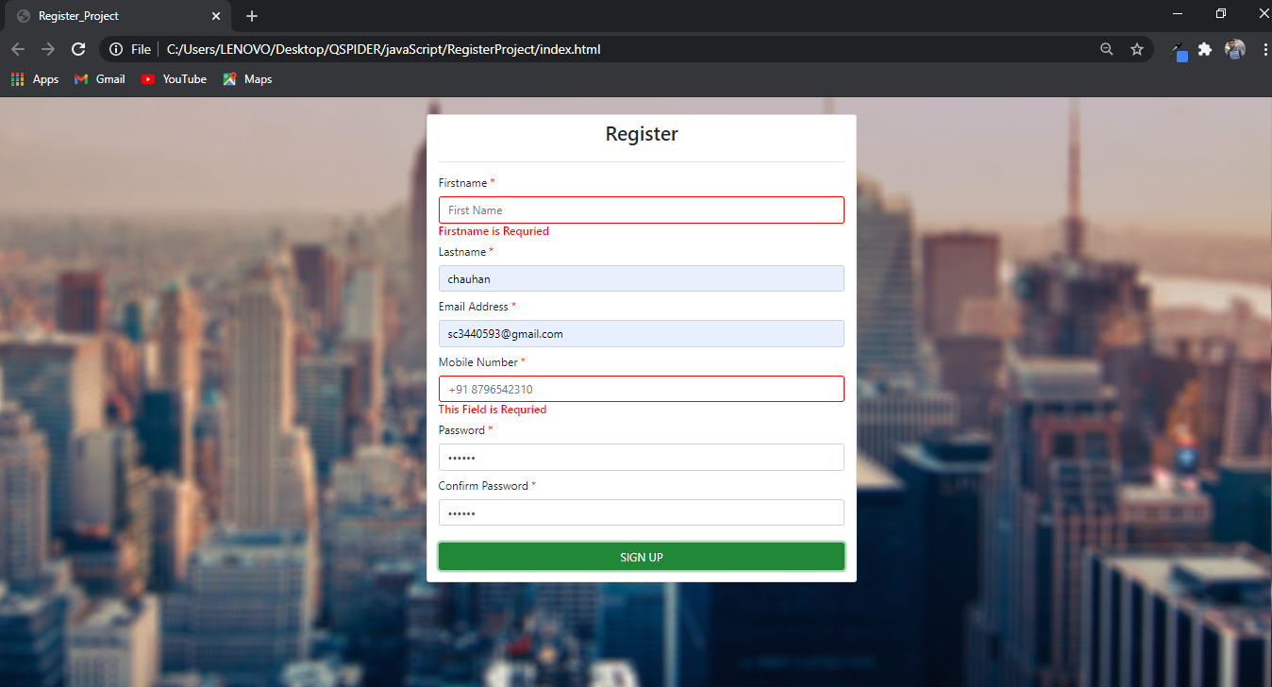

8] FIRSTNAME, PASSWORD IS REQUIRED

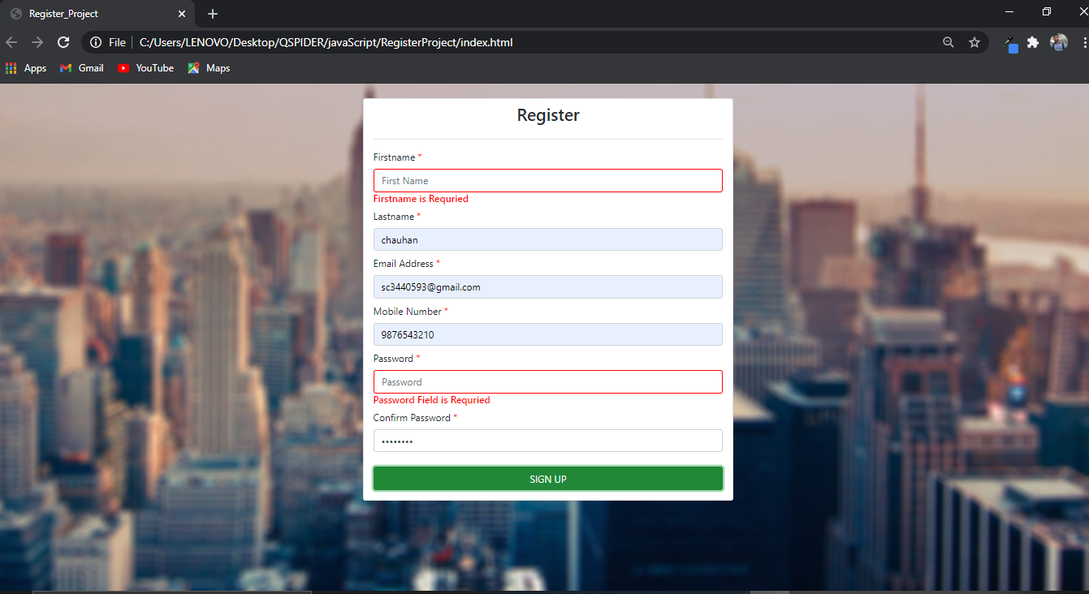

9] FIRSTNAME, CONFIRM PASSWORD IS REQUIRED

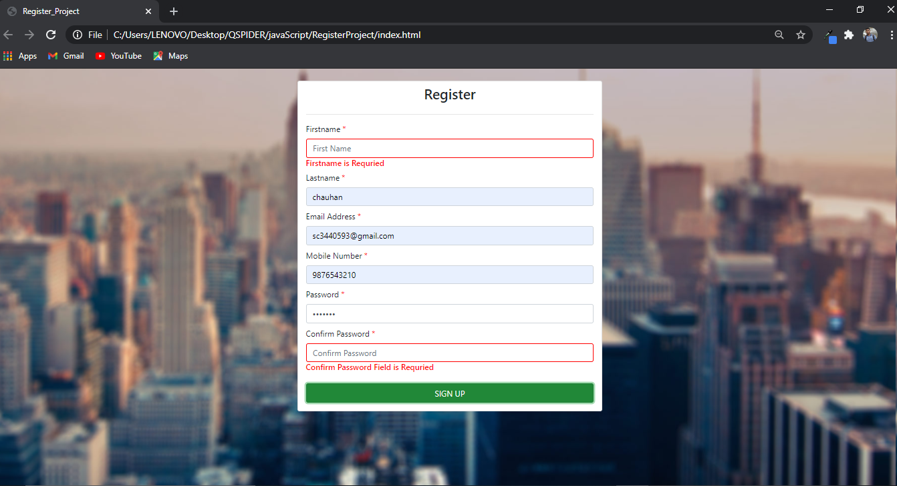

10] FIRSTNAME IS REQUIRED.

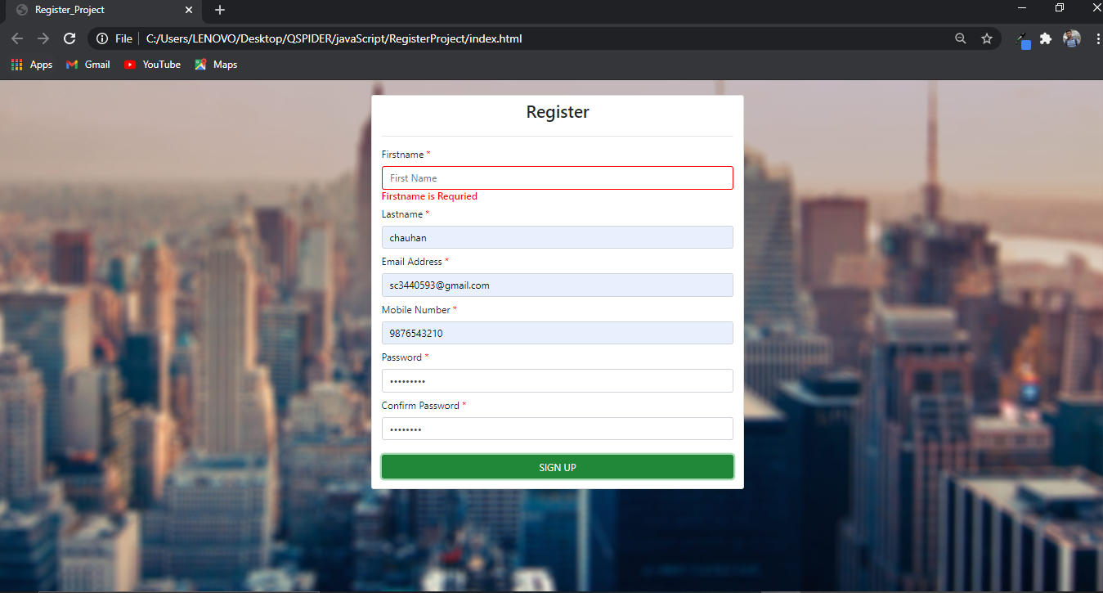

11] FIRSTNAME MUST BE ATLEAST 3 CHARECTER.

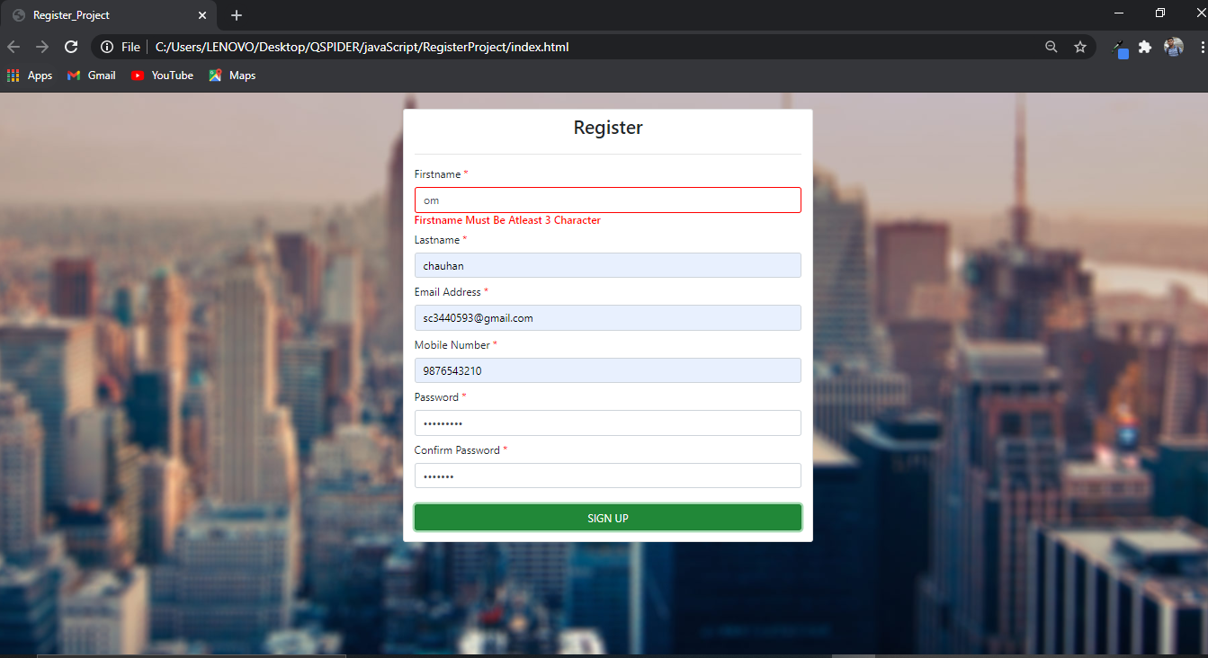

12] FIRSTNAME MUST BE LESS THAN 20 CHARCHTER.

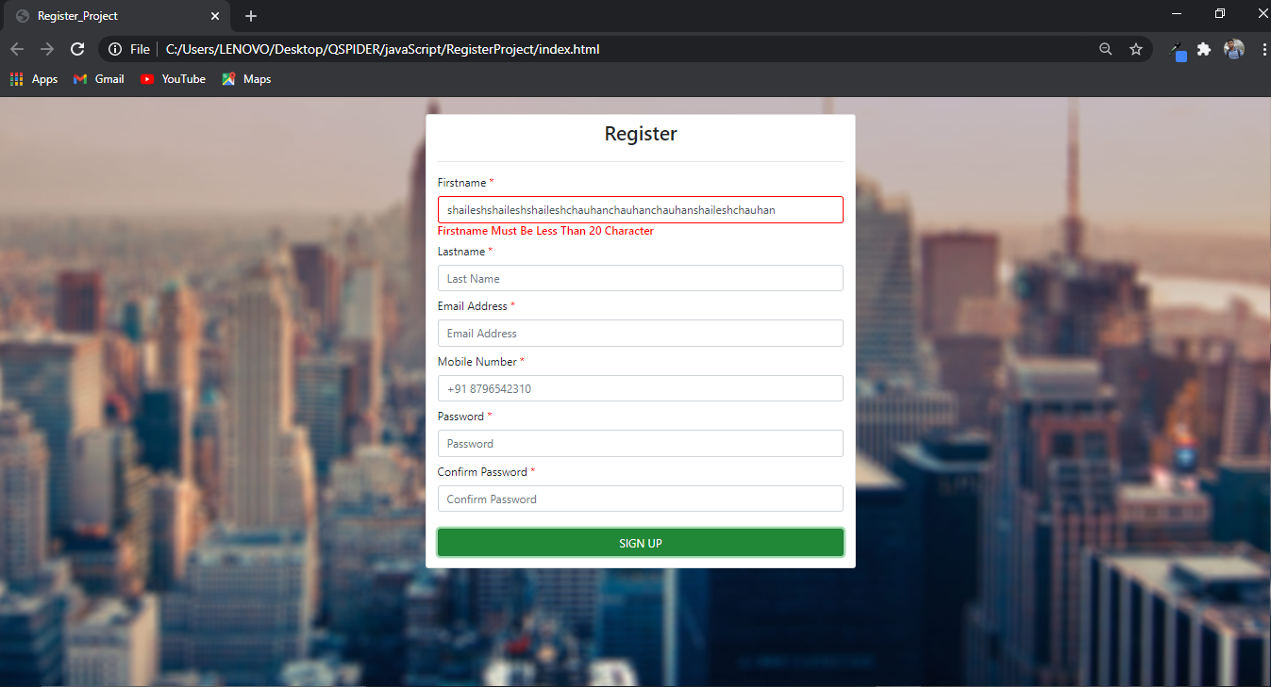

13] FIRSTNAME FIELD ACCEPT ONLY ALPHABETS.

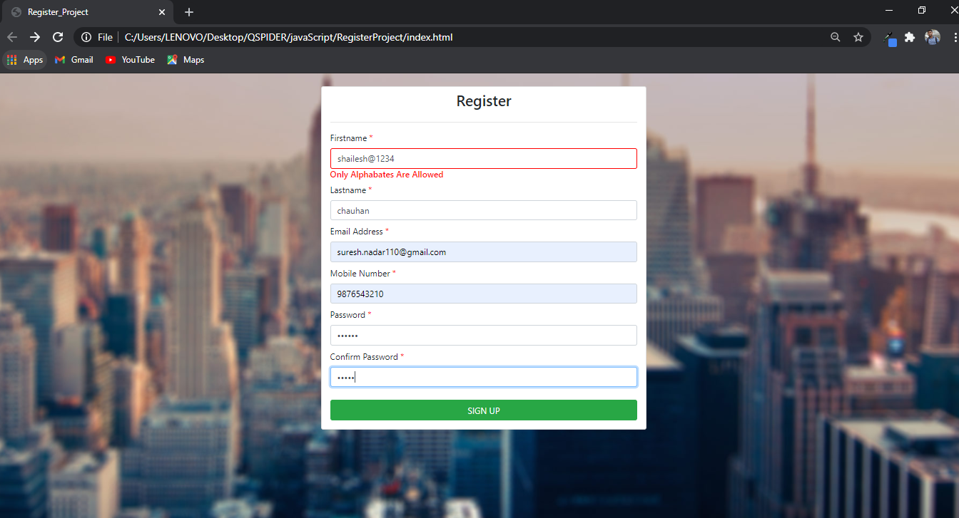

FOR LASTNAME FIELD

1] LASTNAME, EMAIL, MOBILENO, PASSWORD, CONFIRM PASSWORD IS REQUIRED.

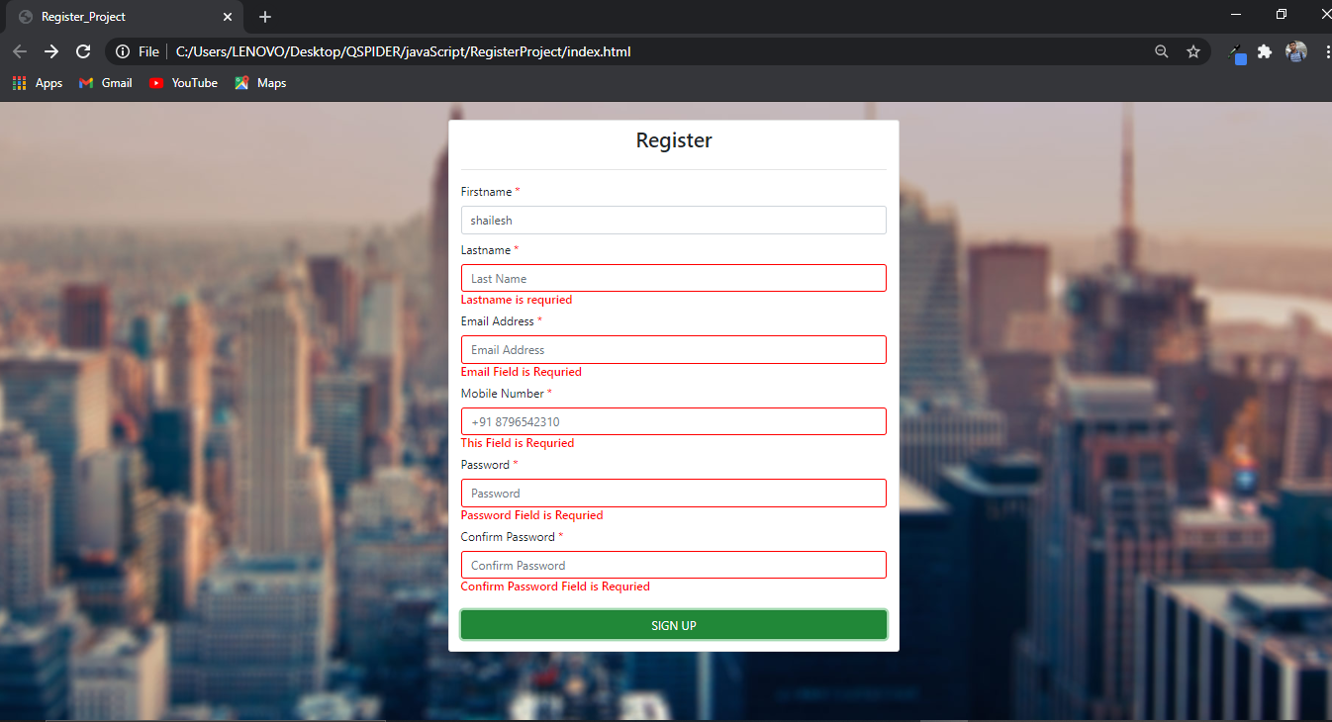

2] LASTNAME, EMAIL, MOBILENO, PASSWORD IS REQUIRED.

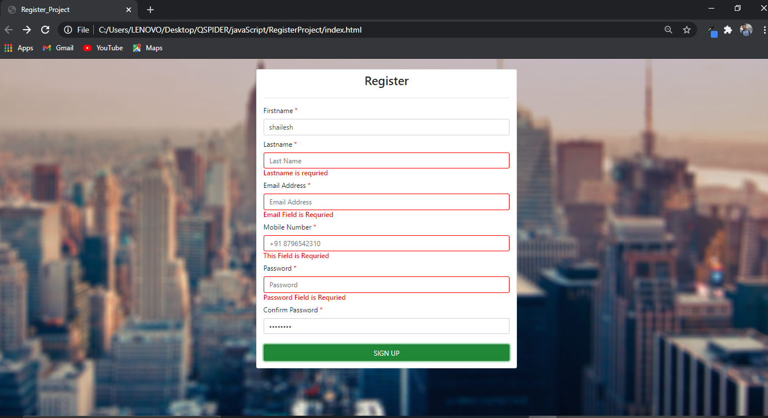

3] LASTNAME, EMAIL, MOBILENO IS REQUIRED.

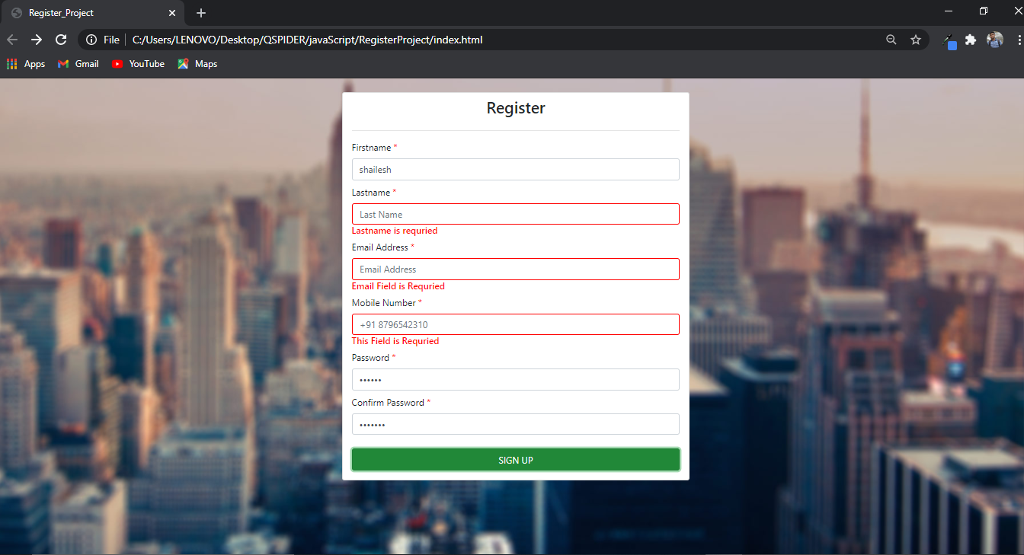

4] LASTNAME, EMAIL IS REQUIRED.

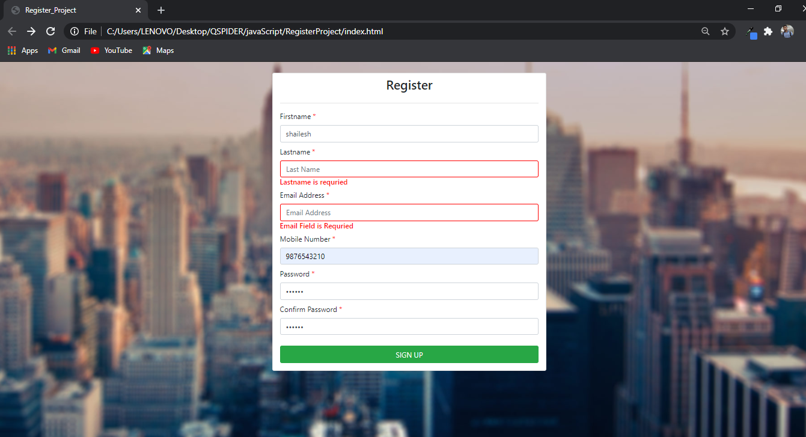

5] LASTNAME, MOBILENO IS REQUIRED.

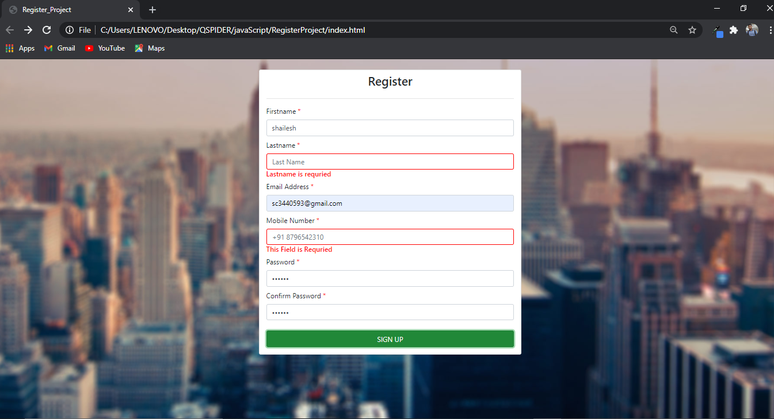

6] LASTNAME, PASSWORD IS REQUIRED.

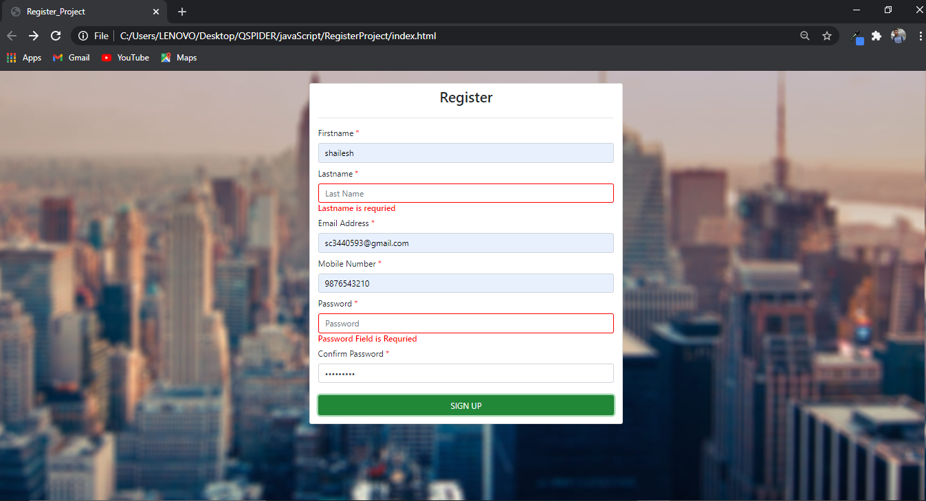

7] LASTNAME, CONFIRM PASSWORD IS REQUIRED.

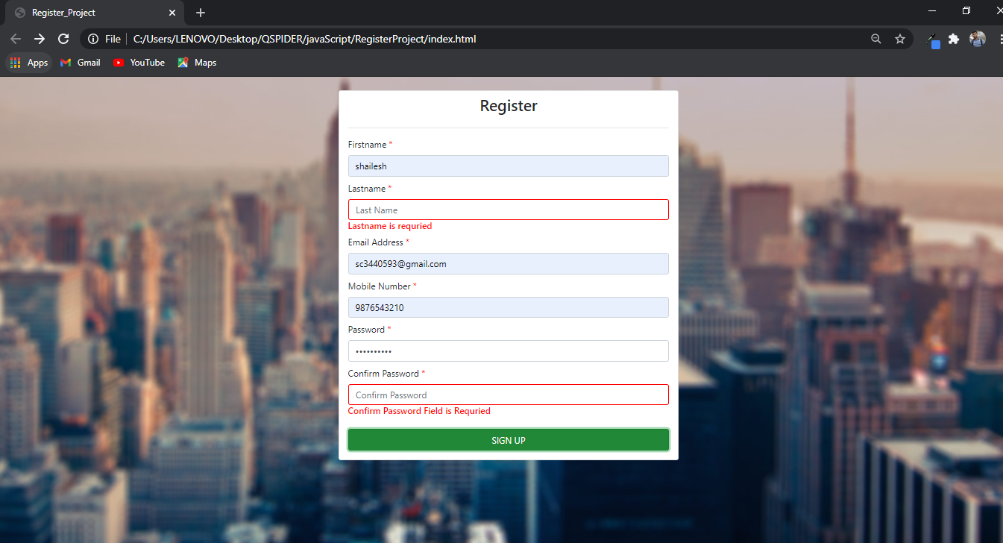

8] LASTNAME IS REQUIRED.

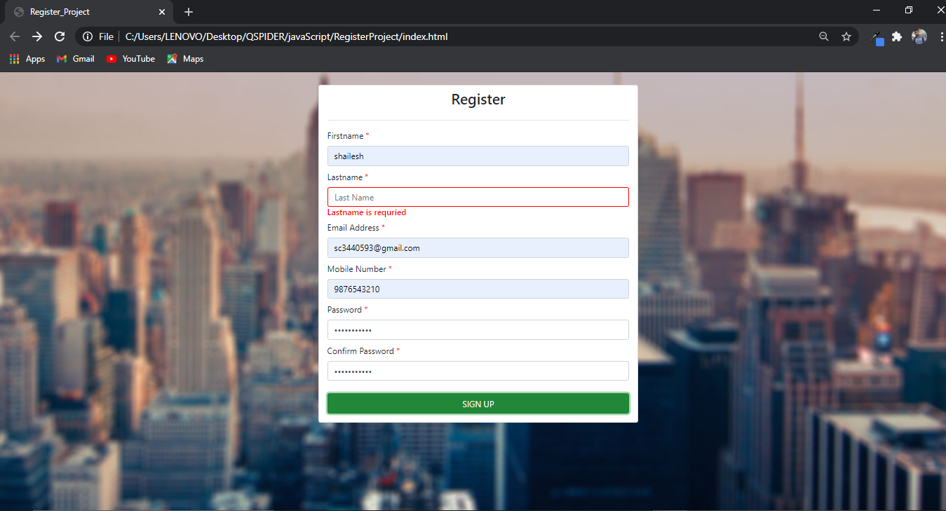

9] LASTNAME MUST BE ATLEAST 3 CHARECTER.

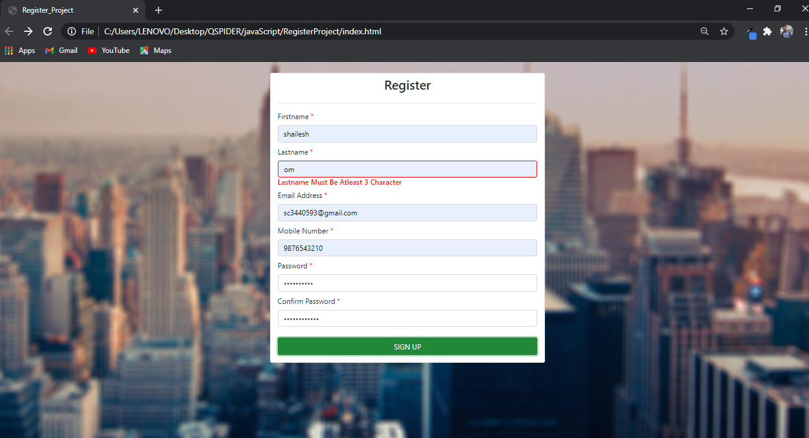

10] LASTNAME MUST BE LESS THAN 20 CHARCHTER.

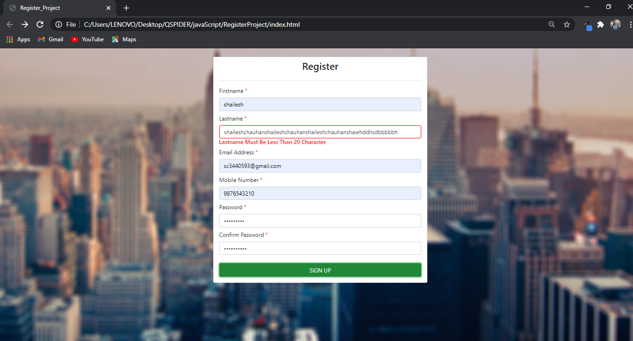

11] LASTNAME FIELD ACCEPT ONLY ALPHABETS.

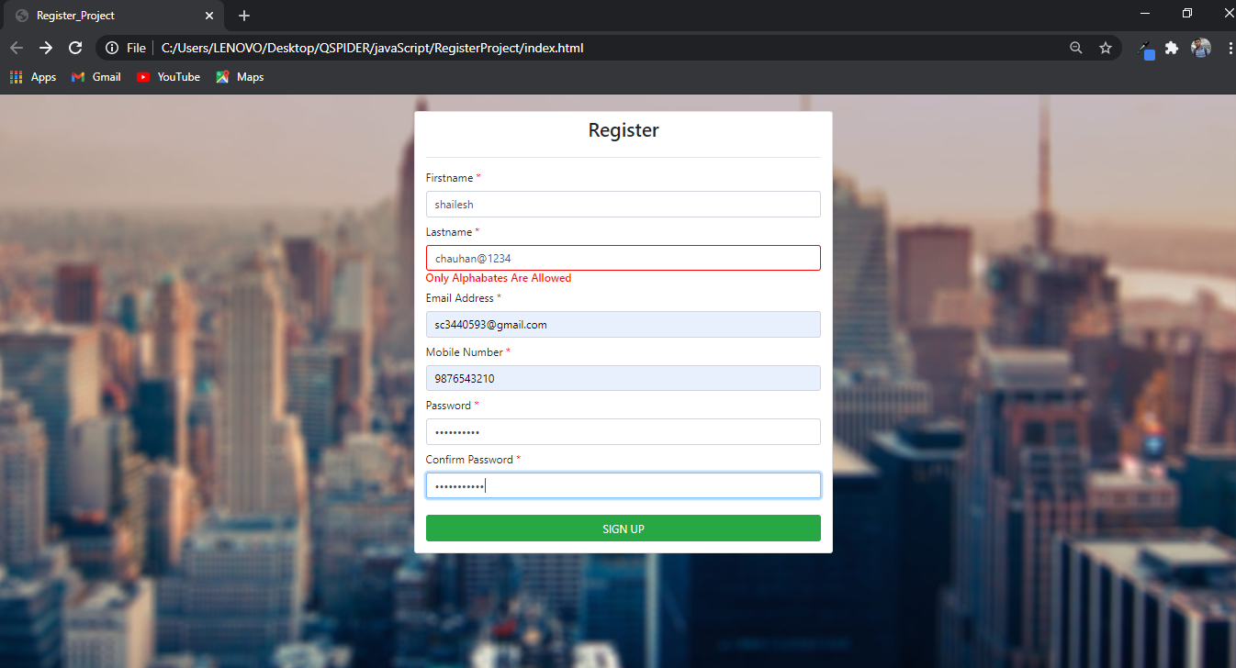

EMAIL FIELD VALIDATION

1] EMAIL, MOBILENO, PASSWORD, CONFIRM PASSWORD IS REQUIRED.

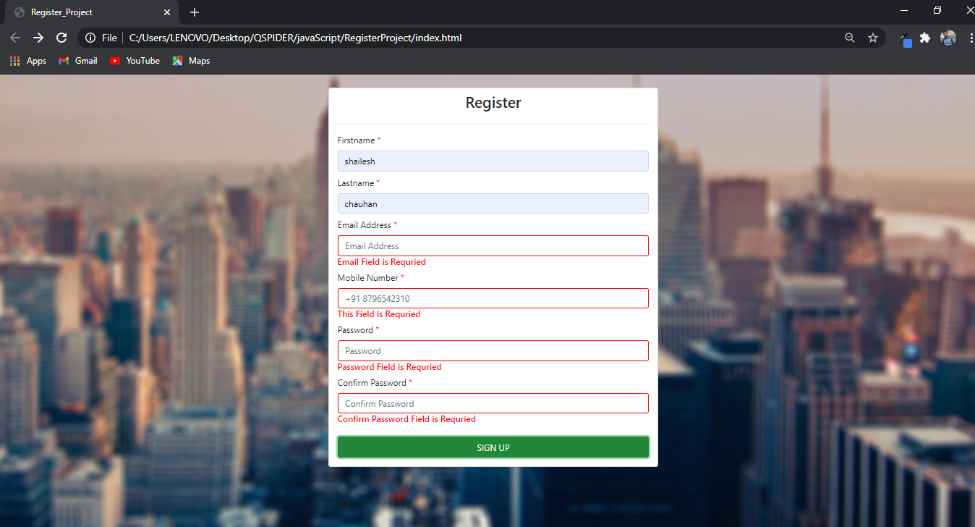

2] EMAIL, MOBILENO, PASSWORD IS REQUIRED.

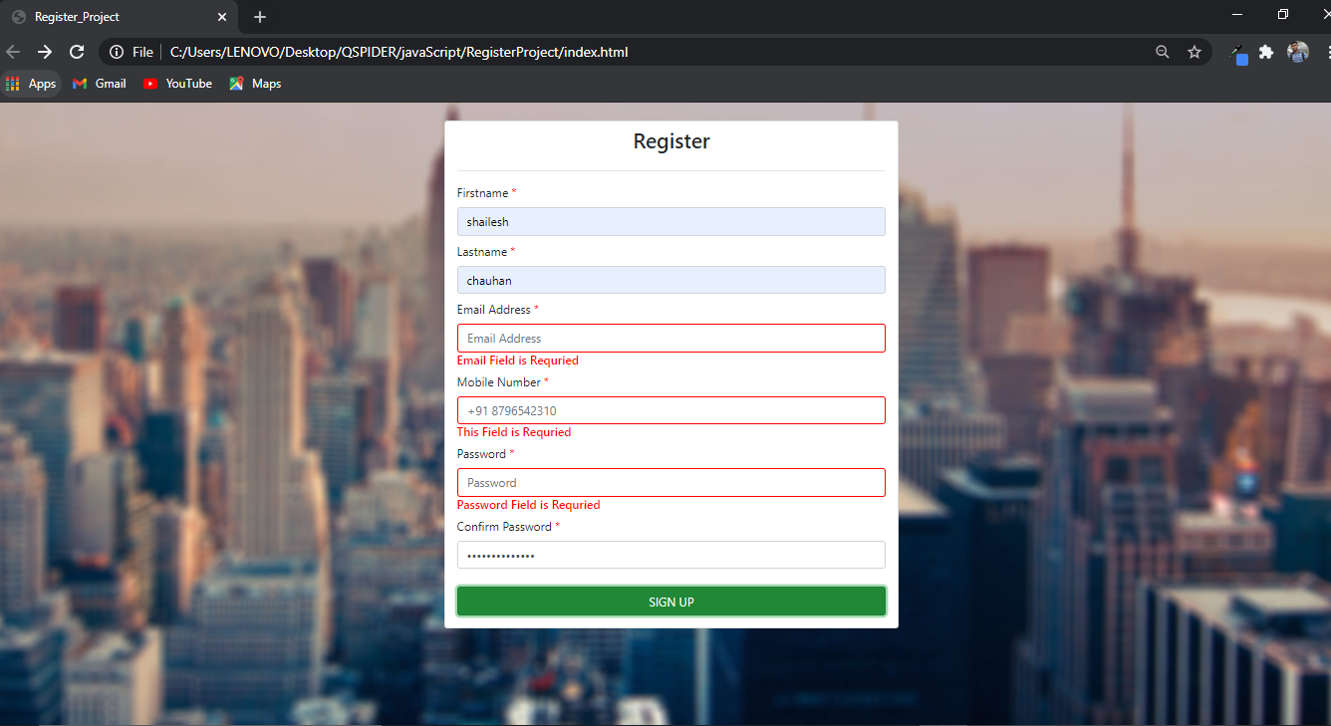

3] EMAIL, MOBILENO IS REQUIRED.

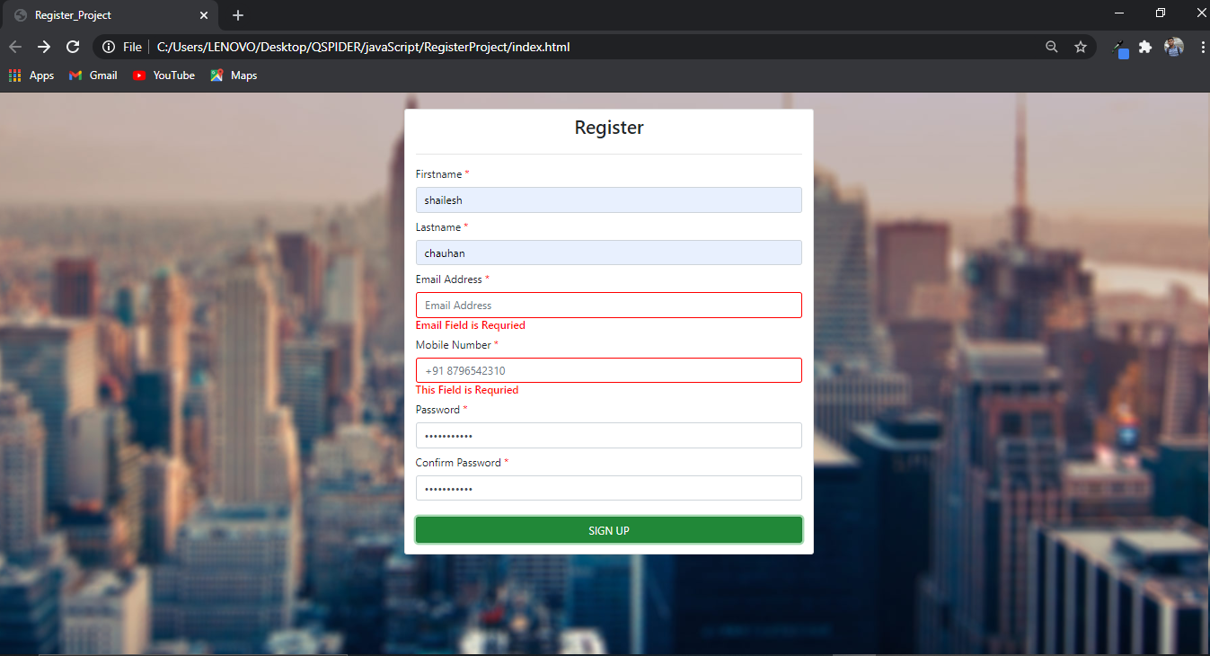

3] EMAIL, PASSWORD IS REQUIRED.

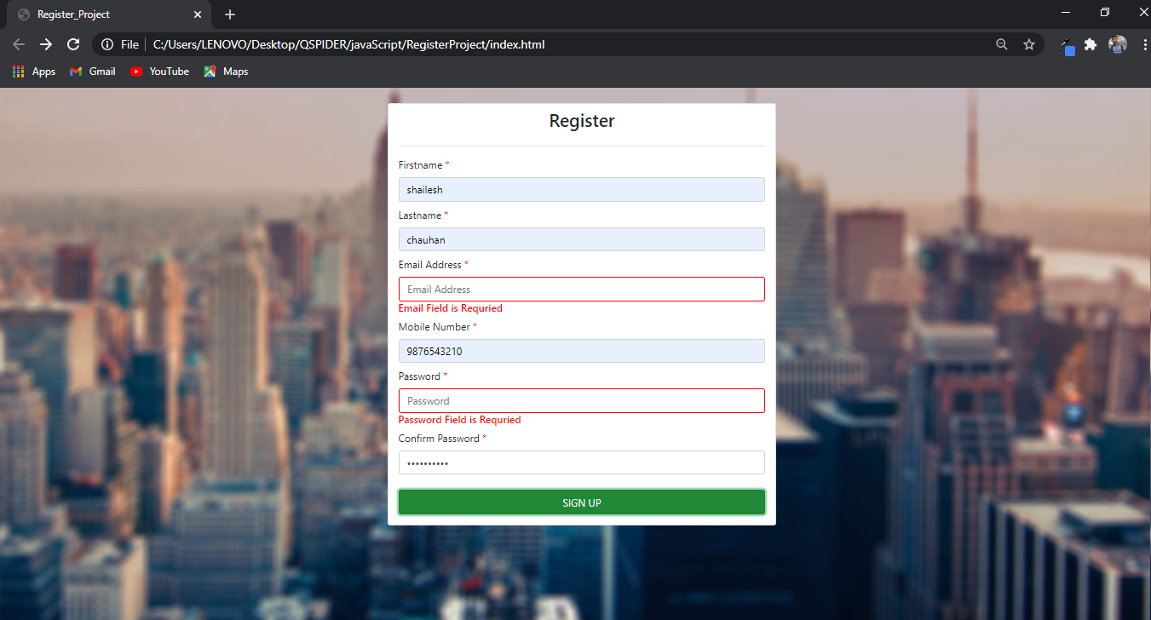

4] EMAIL, CONFIRM PASSWORD IS REQUIRED.

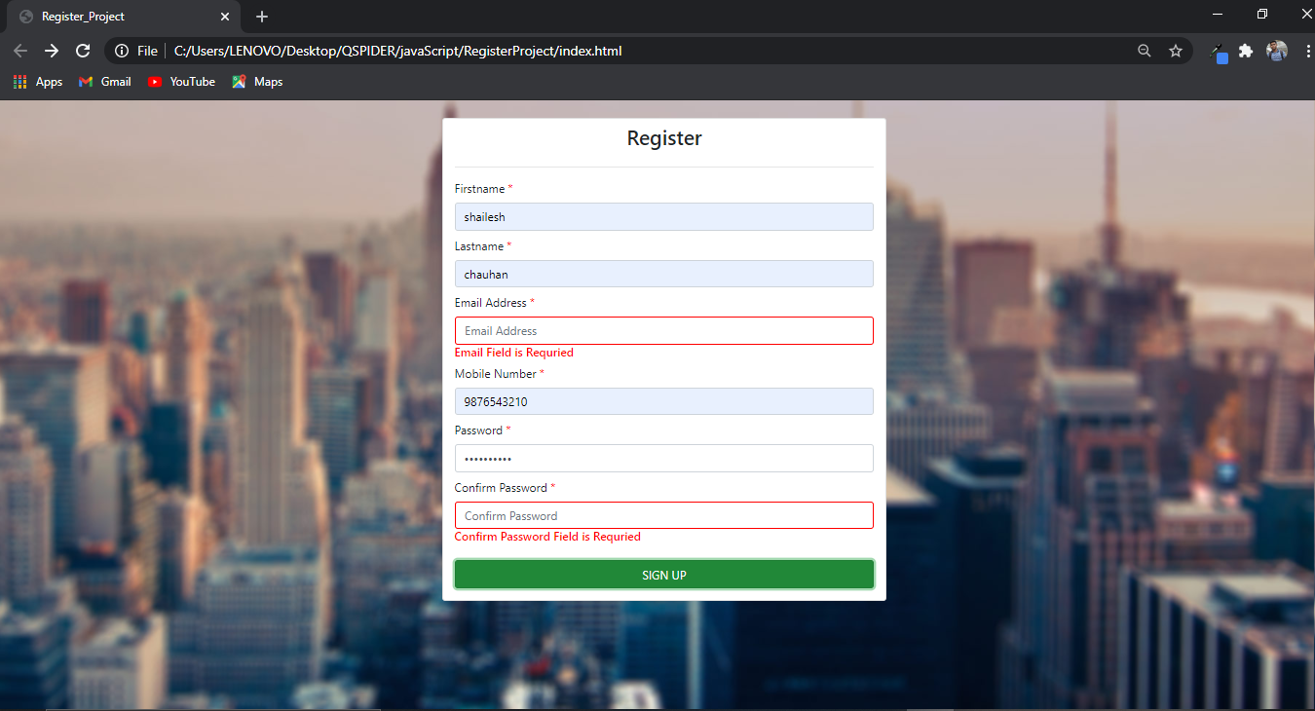

6] EMAIL IS REQIRED

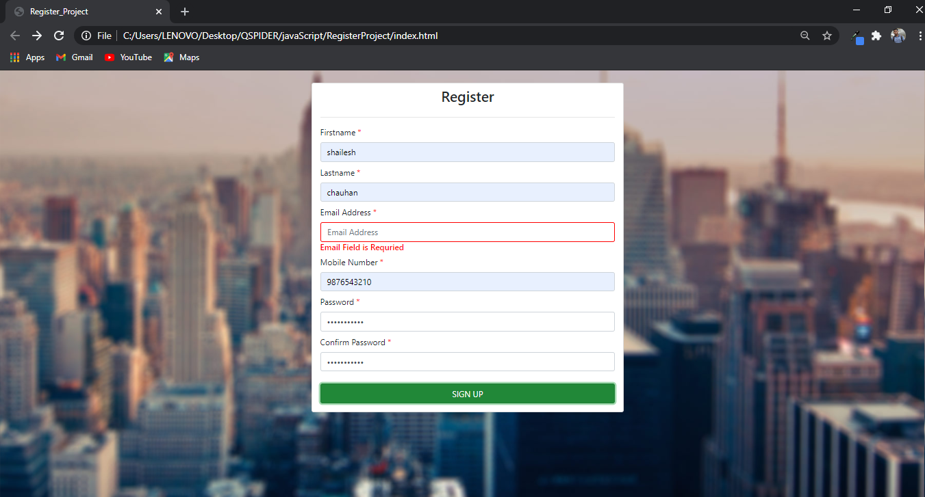

6] VALID EMAIL

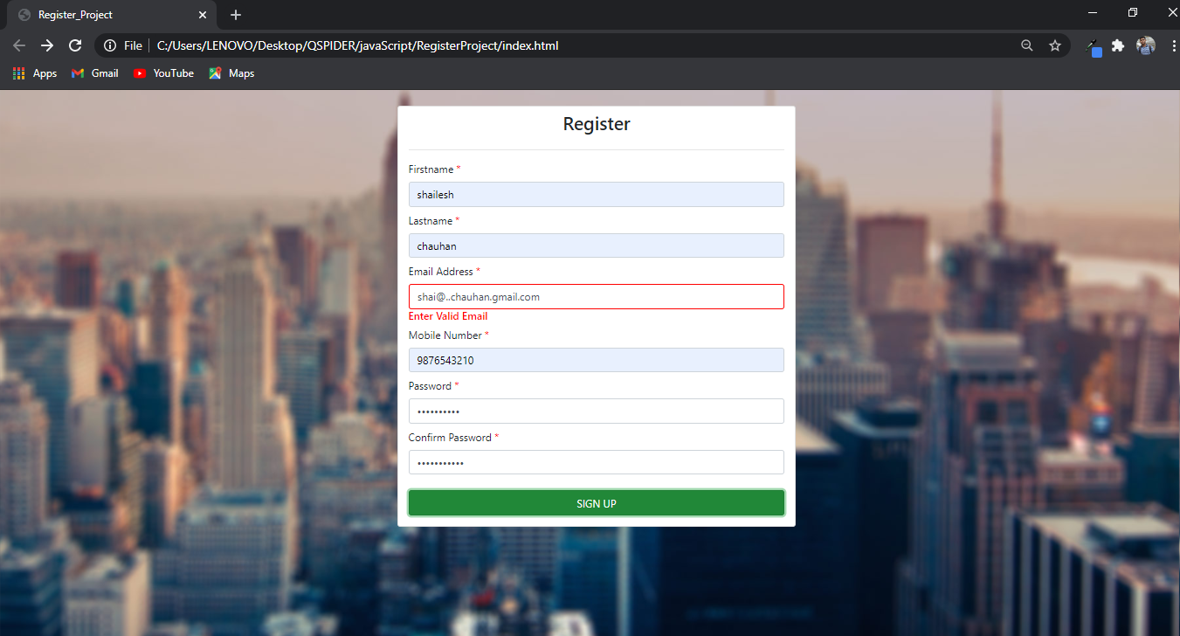

===============================================================================================

FOR MOBILE NUMBER FIELD VALIDATION

1] MOBILENO, PASSWORD, CONFIRM PASSWORD IS REQUIRED.

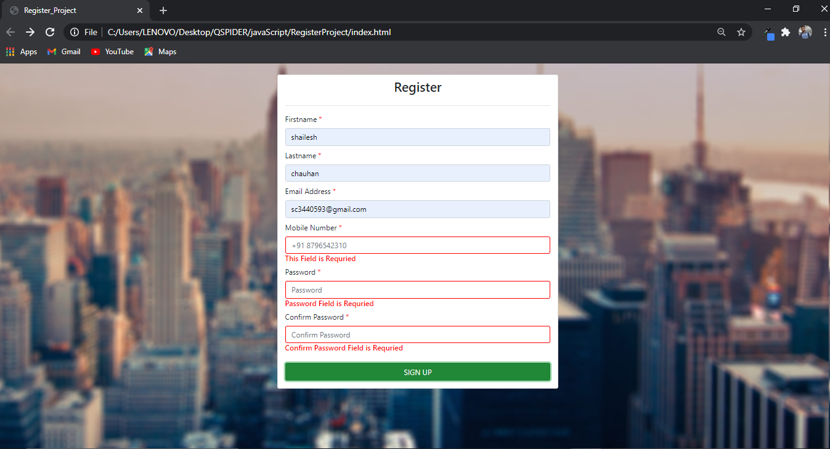

2] MOBILENO, PASSWORD IS REQUIRED.

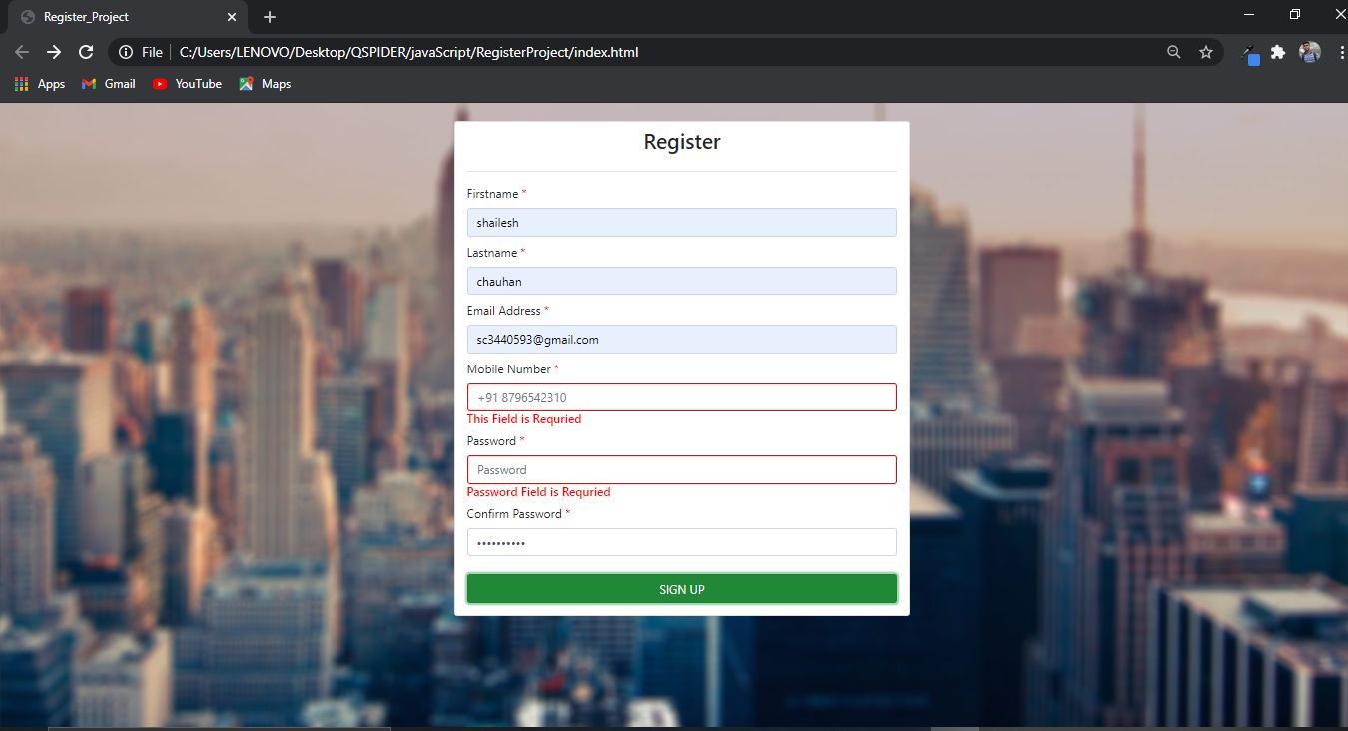

3] MOBILENO, CONFIRM PASSWORD IS REQUIED.

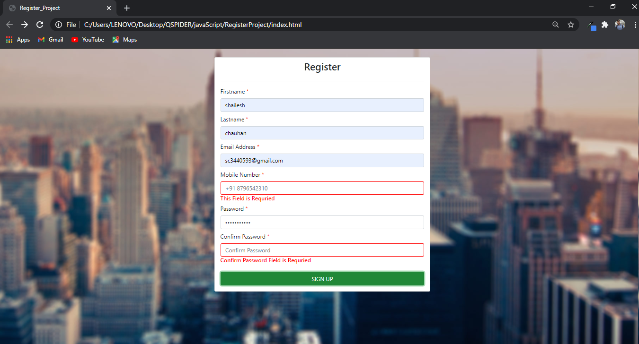

4] MOBILENO, FIRSTNAME, LASTNAME IS REQUIRED.

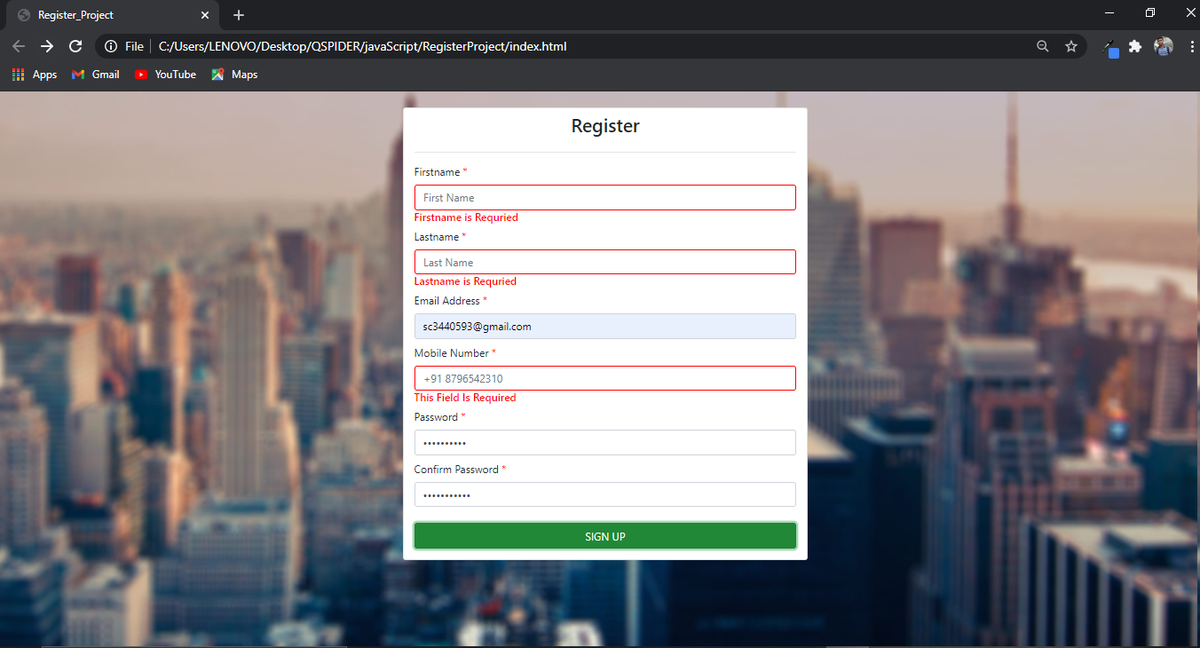

5] MOBILENO IS REQUIRED.

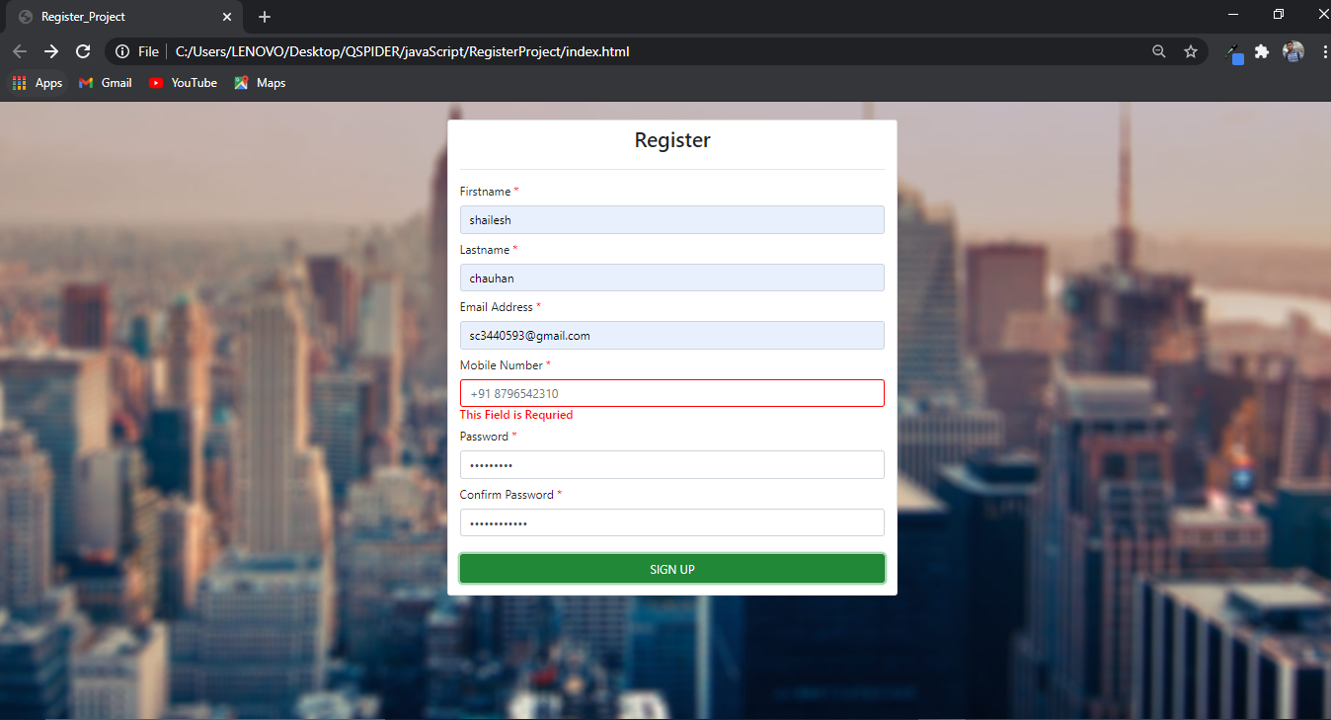

6] VALID MOBILE NUMBER ERROR

A] IF MOBILE NO FIRST DIGIT CONSIST (1 TO 6) IT SHOW INVALID

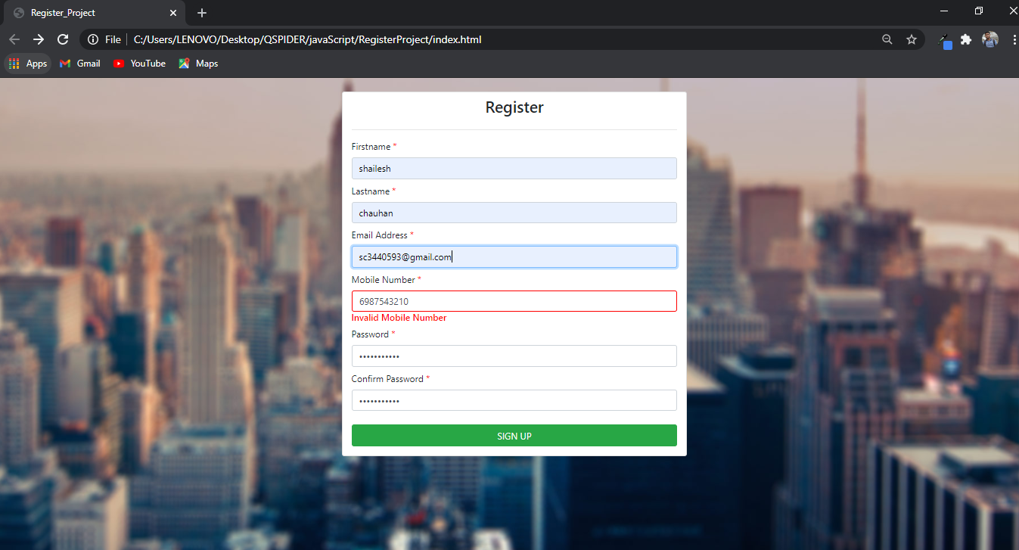

B] IF MOBILE NO CONSIST ONLY 9 DIGITS IS SHOWS ERROR.

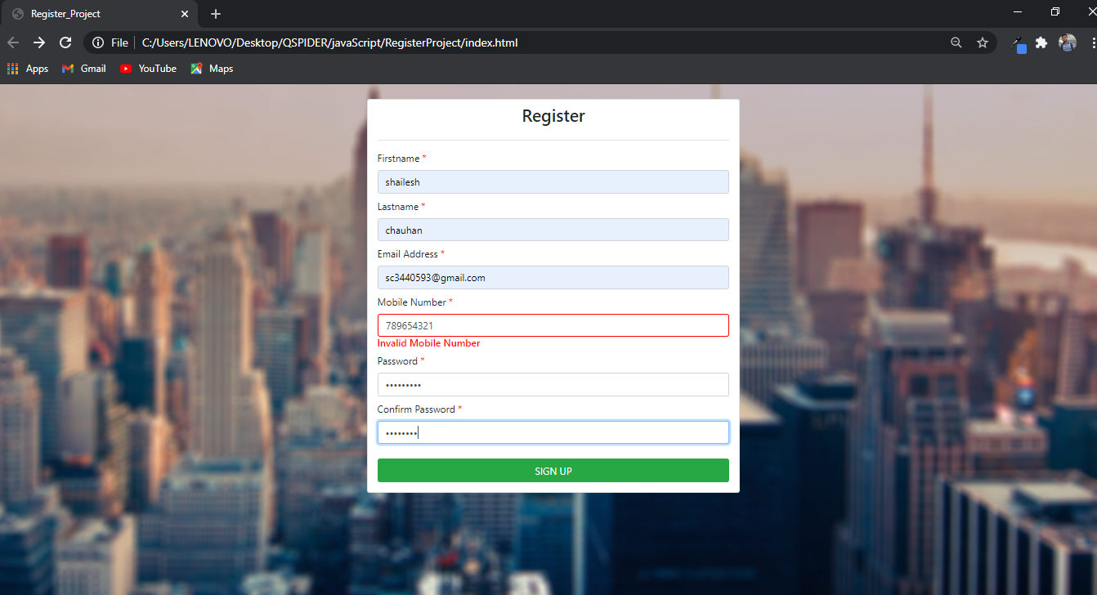

C] IF MOBILE NUMBER CONSISTS MORE THAN 10 DIGITS IT SHOWS ERROR.

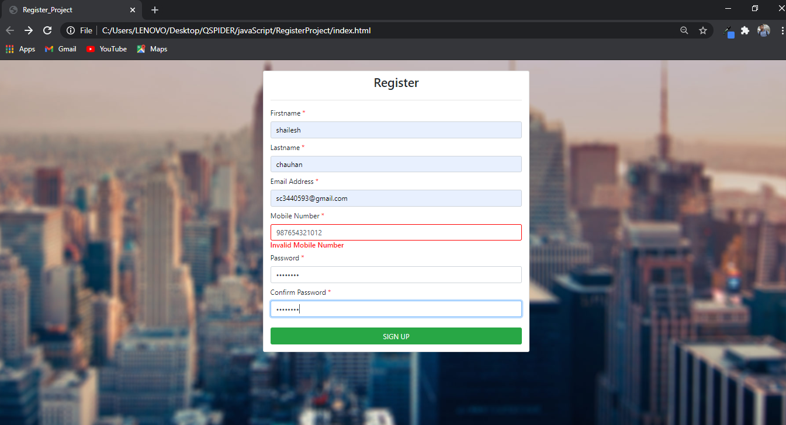

==============================================================================================

PASSWORD FIELD VALIDATION

1] PASSWORD AND CONFIRM PASSWORD FIELD IS REQUIRED.

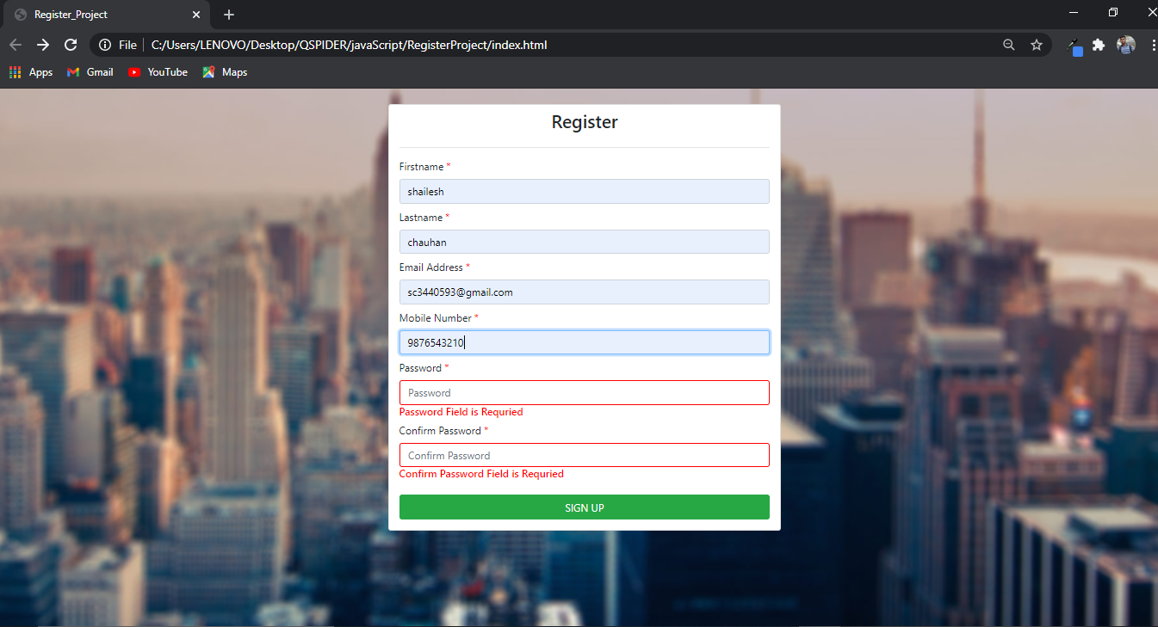

2] PASSWORD IS REQUIRED

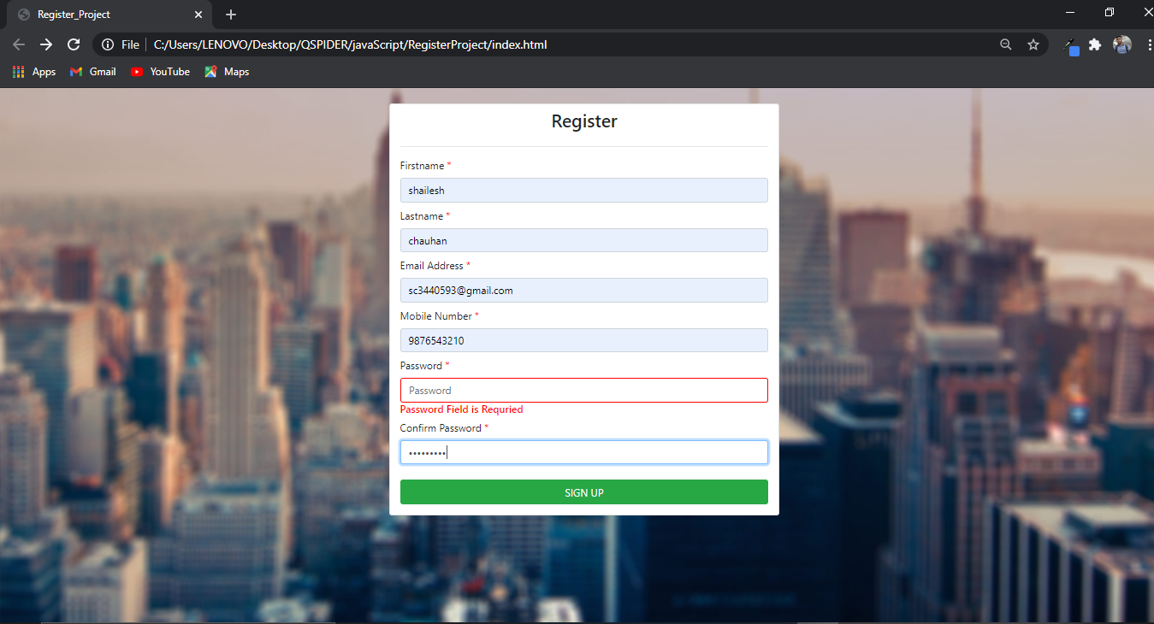

3] CONFIRM PASSWORD FIELD IS REQUIRED

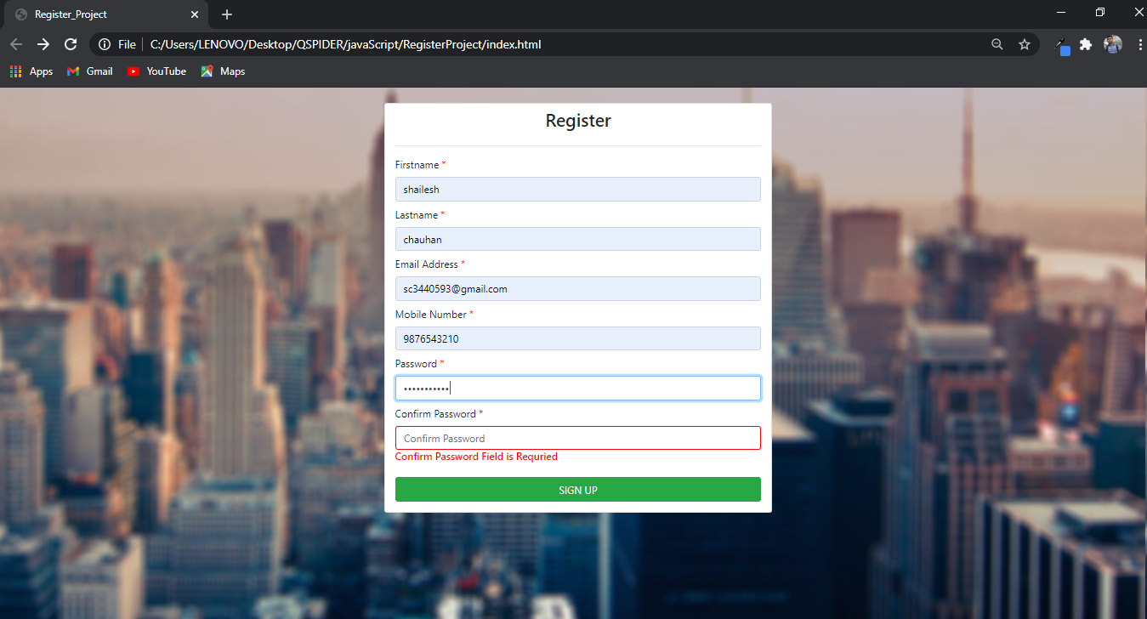

3] VALID PASSWORD PASSWORD.

A] ATLEAST ONE DIGIT ----[0-9]

B] ATLEAST ONE LOWERCASE CHARACTER-----[a-z]

C] ATLEAST ONE UPPERCASE CHARACTER----[A-Z]

D] ATLEAST ONE SPECIAL CHARACTER---[*.!@#$%^&(){}[]:;<>,.?\|/+=-]

E] ATLEAST 8 CHARACTERS IN LENGTH, BUT NOT MORE THAN 32

**REGURAL EXPRESSION =”^(?=.*[0-9])(?=.*[a-z])(?=.*[*.!@#$%^&(){}[]:;<>,.?\|/+=-]).{8,32}$”**

Password= shailesh@chauhan

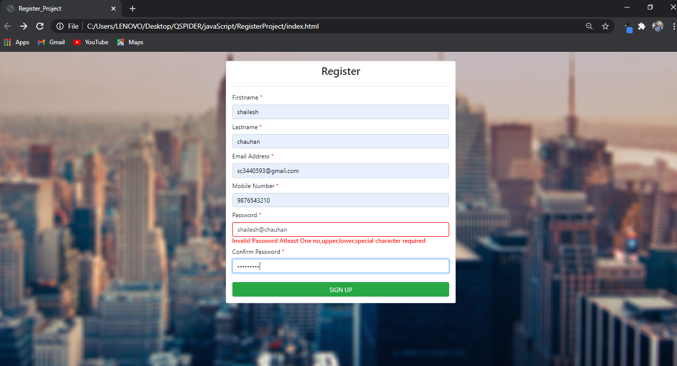

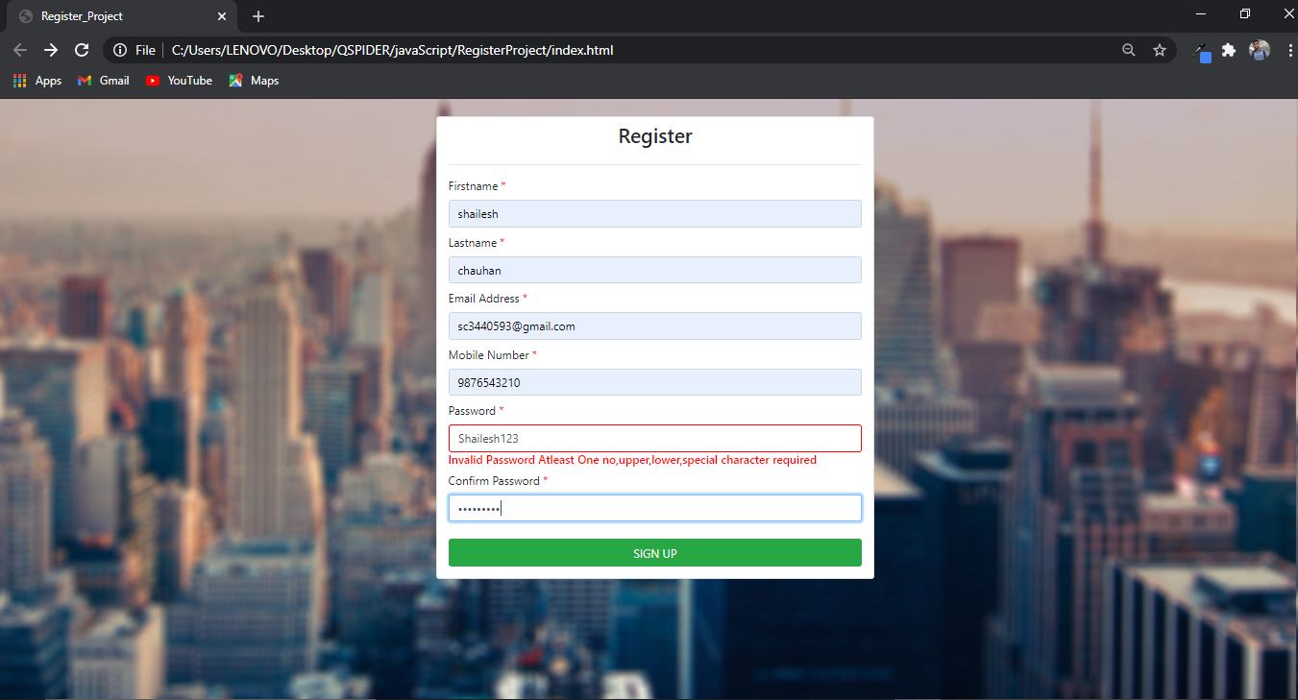

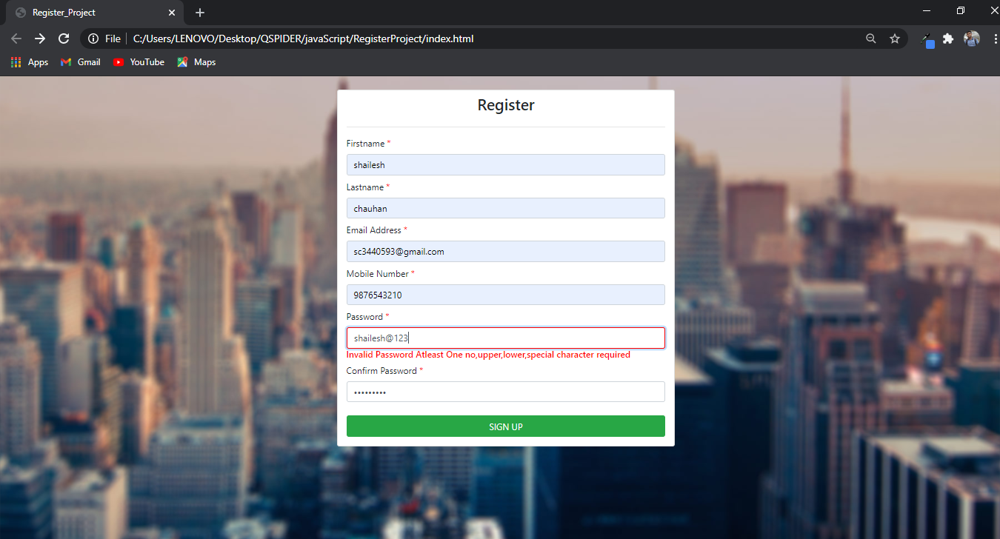

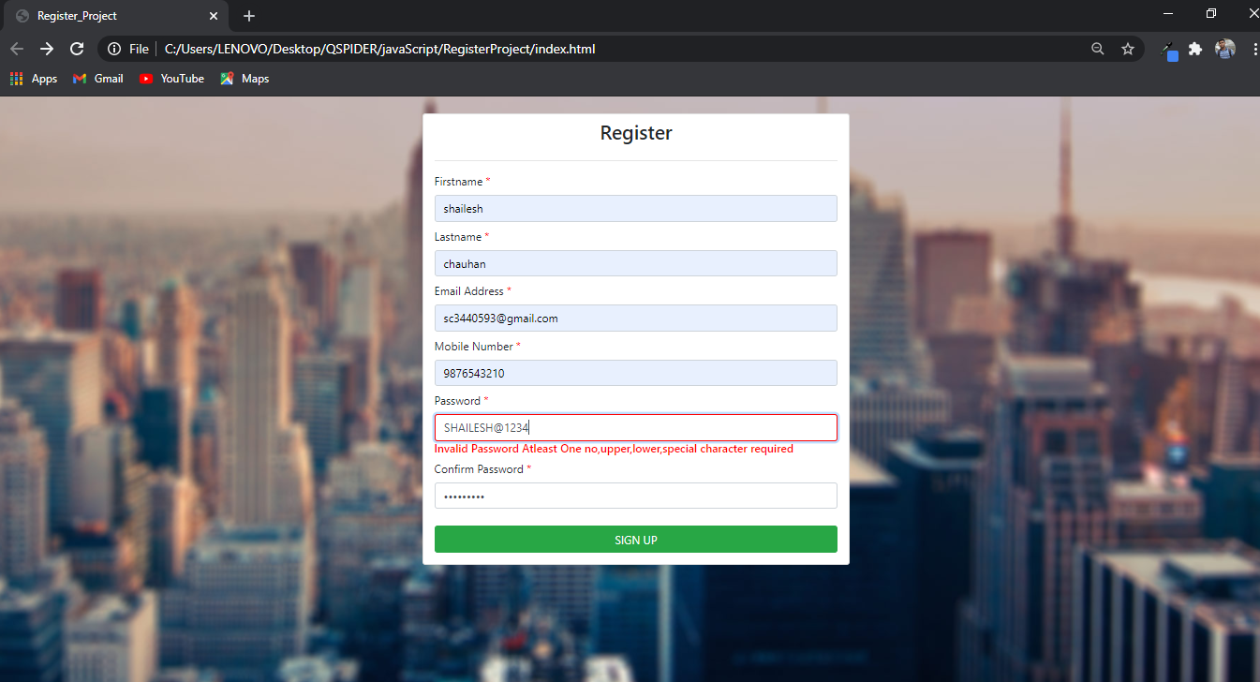

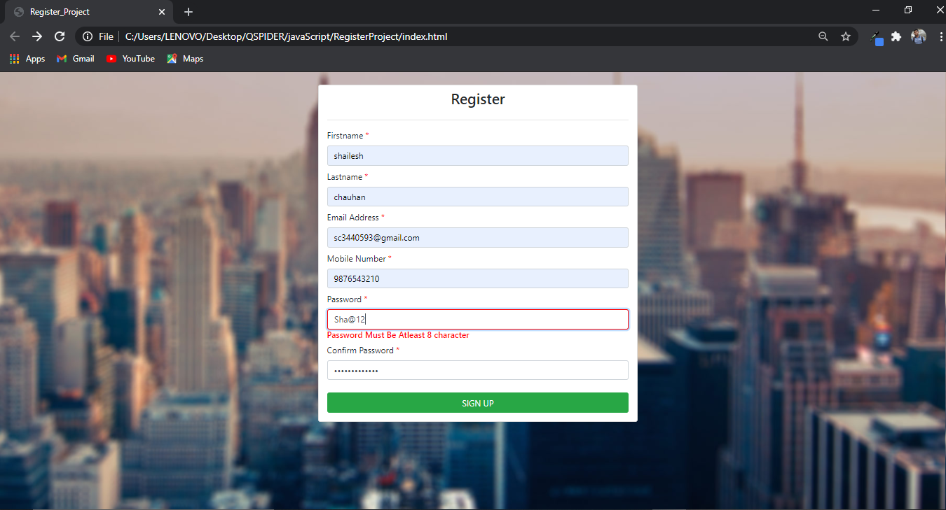

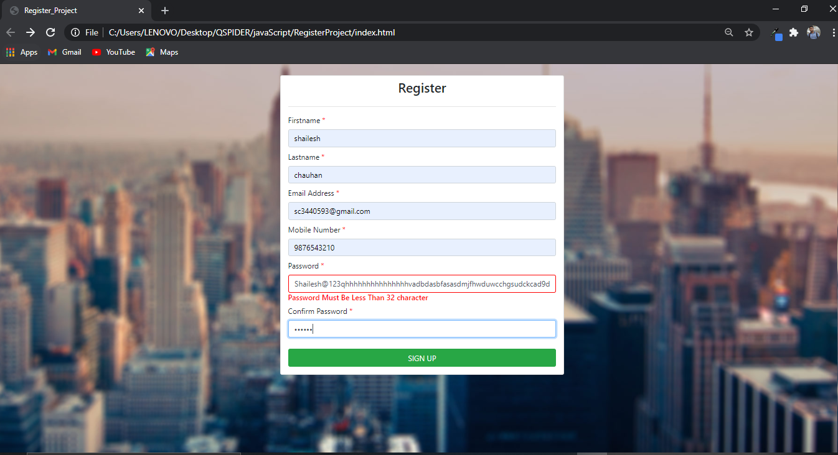

If We want to validate Confirm Password Repeat same step which is done in password field

IF PASSWORD OR CONFIRM PASSWORD IS NOT MATCHED IT SHOW ERROR

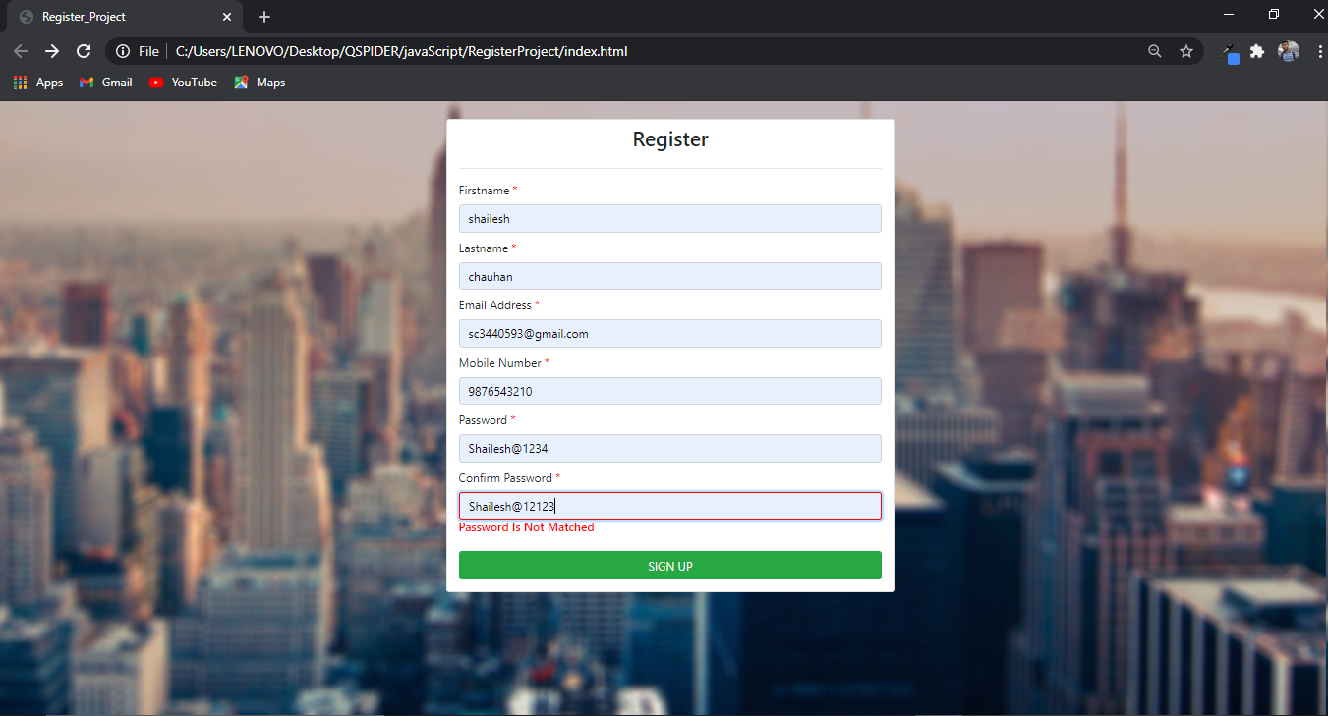

VALID SENARIO

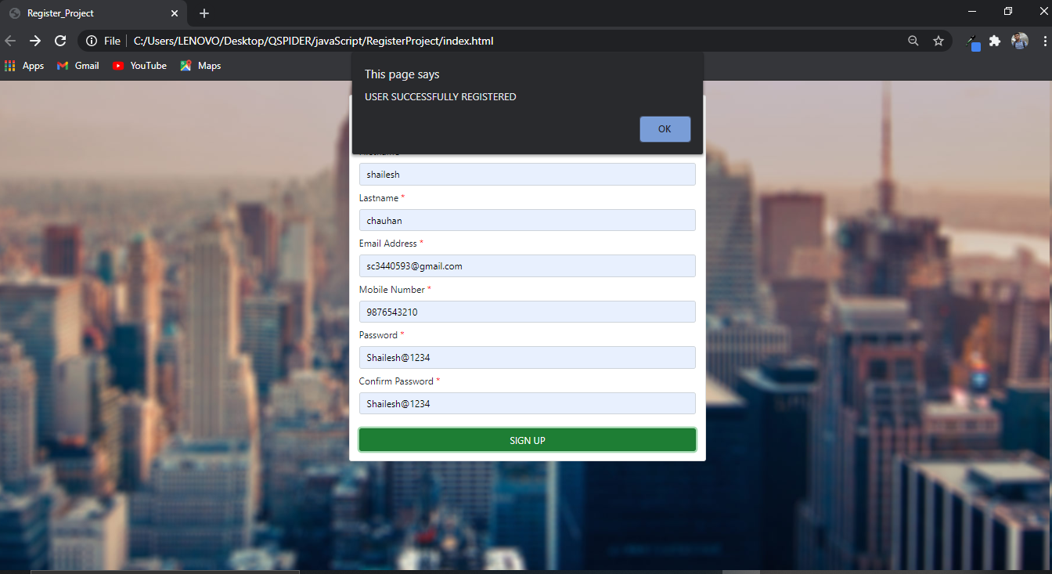

AFTER CLICKING ON POP-UP OK BUTTON, IT NAVIGATE TO ONE PAGE TO ANOTHER PAGE

